**Install Docker Toolbox on Windows**

Docker Toolbox

Windows users use Docker Toolbox to install Docker software. Docker Toolbox includes the following Docker tools:

* Docker CLI client for running Docker Engine to create images and containers
* Docker Machine so you can run Docker Engine commands from Windows terminals
* Docker Compose for running the docker-compose command
* Kitematic, the Docker GUI
* the Docker QuickStart shell preconfigured for a Docker command-line environment
* Oracle VM VirtualBox

Because the Docker Engine daemon uses Linux-specific kernel features, you can’t run Docker Engine natively in Windows. Instead, you must use the Docker Machine command, docker-machine, to create and attach to a small Linux VM on your machine. This VM hosts Docker Engine for you on your Windows system.

## Check your version

To run Docker, your machine must have a 64-bit operating system running Windows 7 or higher. Additionally, you must make sure that virtualization is enabled on your machine. To verify your machine meets these requirements, do the following:

1. Right click the windows message and choose **System**.

If you aren’t using a supported version, you could consider upgrading your operating system.

If you have a newer system, specifically 64bit Windows 10 Pro, with Enterprise and Education (1511 November update, Build 10586 or later), consider using [Docker for Windows](https://docs.docker.com/docker-for-windows) instead. It runs natively on the Windows, so there is no need for a pre-configured Docker QuickStart shell. It also uses Hyper-V for virtualization, so the instructions below for checking virtualization will be out of date for newer Windows systems. Full install prerequisites are provided in the Docker for Windows topic in [What to know before you install](https://docs.docker.com/docker-for-windows/#what-to-know-before-you-install).

1. Make sure your Windows system supports Hardware Virtualization Technology and that virtualization is enabled.

**For Windows 8 or 8.1**

Choose **Start > Task Manager** and navigate to the **Performance** tab. Under **CPU** you should see the following:

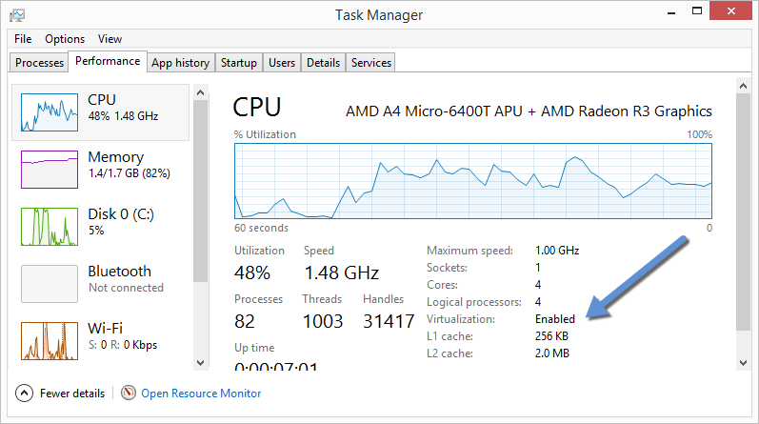

If virtualization is not enabled on your system, follow the manufacturer’s instructions for enabling it.

**For Windows 7**

Run the [Microsoft® Hardware-Assisted Virtualization Detection Tool](http://www.microsoft.com/en-us/download/details.aspx?id=592) and follow the on-screen instructions.

1. Verify your Windows OS is 64-bit (x64)

How you do this verification depends on your Windows version.

## Step 2: Install Docker Toolbox

In this section, you install the Docker Toolbox software and several “helper” applications. The installation adds the following software to your machine:

* Docker Client for Windows
* Docker Toolbox management tool and ISO
* Oracle VM VirtualBox
* Git MSYS-git UNIX tools

If you have a previous version of VirtualBox installed, do not reinstall it with the Docker Toolbox installer. When prompted, uncheck it.

If you have Virtual Box running, you must shut it down before running the installer.

Docker Toolbox Install

1. Go to the [Docker Toolbox](https://www.docker.com/toolbox) page.
2. Click the installer link to download.
3. Install Docker Toolbox by double-clicking the installer.

The installer launches the “Setup - Docker Toolbox” dialog.

If Windows security dialog prompts you to allow the program to make a change, choose **Yes**. The system displays the **Setup - Docker Toolbox for Windows** wizard.

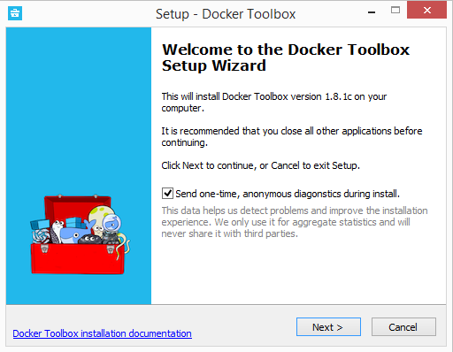

1. Press **Next** to accept all the defaults and then **Install**.

Accept all the installer defaults. The installer takes a few minutes to install all the components:

1. When notified by Windows Security the installer will make changes, make sure you allow the installer to make the necessary changes.

When it completes, the installer reports it was successful:

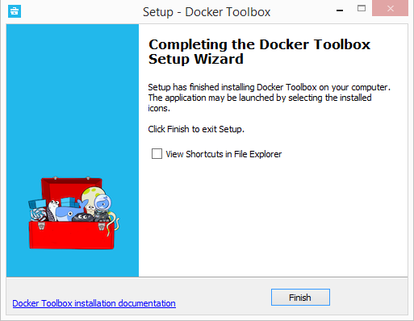

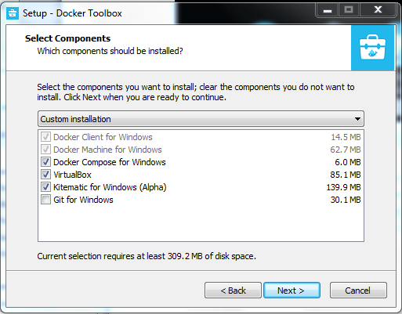

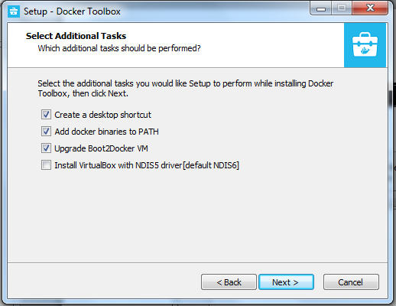

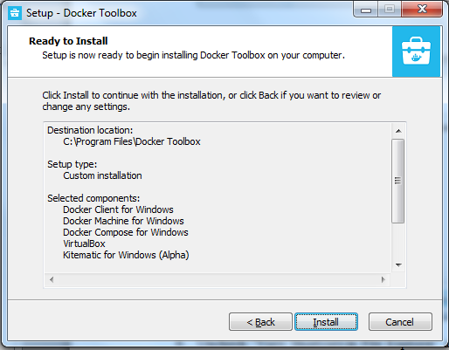

1. Uncheck “View Shortcuts in File Explorer” and press **Finish**.

## Step 3: Verify your installation

The installer places Docker Toolbox and VirtualBox in your **Applications** folder. In this step, you start Docker Toolbox and run a simple Docker command.

1. On your Desktop, find the Docker Toolbox icon.

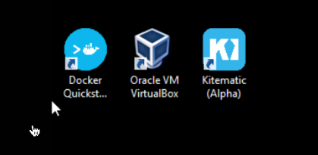

1. Click the icon to launch a Docker Toolbox terminal.

If the system displays a **User Account Control** prompt to allow VirtualBox to make changes to your computer. Choose **Yes**.

The terminal does several things to set up Docker Toolbox for you. When it is done, the terminal displays the $ prompt.

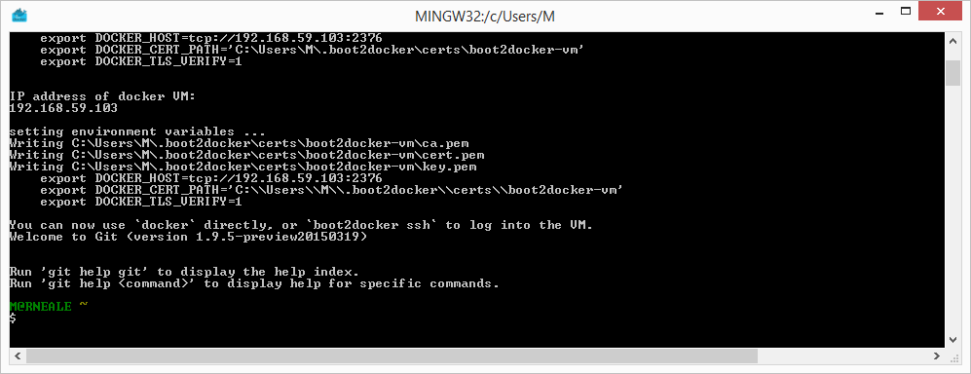

The terminal runs a special bash environment instead of the standard Windows command prompt. The bash environment is required by Docker.

1. Make the terminal active by click your mouse next to the $ prompt.

If you aren’t familiar with a terminal window, here are some quick tips.



The prompt is traditionally a $ dollar sign. You type commands into the command line which is the area after the prompt. Your cursor is indicated by a highlighted area or a | that appears in the command line. After typing a command, always press RETURN.

1. Type the docker run hello-world command and press RETURN.

The command does some work for you, if everything runs well, the command’s output looks like this:

|  |
| --- |
| $ docker run hello-world  Unable to find image 'hello-world:latest' locally  Pulling repository hello-world  91c95931e552: Download complete  a8219747be10: Download complete  Status: Downloaded newer image for hello-world:latest  Hello from Docker.  This message shows that your installation appears to be working correctly.  To generate this message, Docker took the following steps:  1. The Docker Engine CLI client contacted the Docker Engine daemon.  2. The Docker Engine daemon pulled the "hello-world" image from the Docker Hub.  (Assuming it was not already locally available.)  3. The Docker Engine daemon created a new container from that image which runs the  executable that produces the output you are currently reading.  4. The Docker Engine daemon streamed that output to the Docker Engine CLI client, which sent it  to your terminal.  To try something more ambitious, you can run an Ubuntu container with:  $ docker run -it ubuntu bash  For more examples and ideas, visit:  https://docs.docker.com/userguide/ |

References

<https://docs.docker.com/toolbox/toolbox_install_windows/>